A CLASSROOM FOR EVERYONE
SPE 710

Basic Premise: A classroom that invites all children to a joyful environment will have a positive impact on learning outcomes.

Overall the classroom looks like:
- When you enter the room, the classroom will be very appealing and inviting visually.
- Very colorful.

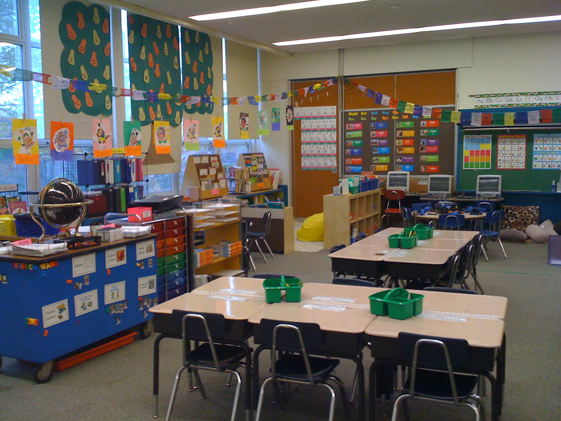

Furniture
- Children’s bins for their supplies would be different colors with labels in large font.
- Tables in the room will be adjustable height. Some will be tall for standing and doing work; some could be low for sitting.
- Chairs range from the ball chair (2), cube chairs (3) regular chairs (10), Rifton chairs (2), bean bags- for the reading area (2)
- Weighted blanket and cushions for children to use for compression
- Nice shaggy rug
- Bookshelves low and high
- Display bookshelves

Equipment
- Board Slants (10)
- Timed timers (10)
- Headphones (10) with volume control and left and right hearing distinguishers
- Visual Schedule
- Magnifiers
- Link-cubes
- PVC earphones (5)

High Technology
- Wireless internet access
- Photo Printer
- Laser Printer
- MacBook’s (10) with keyboards for little hands to use
- Ipads (10) with $200 to spend on apps
- Elmo
- Smart board

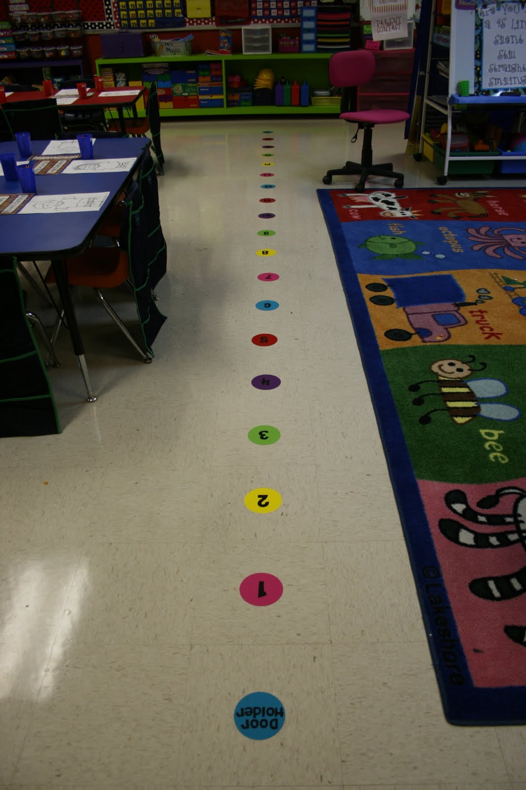
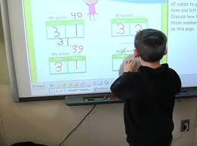

Materials
- Stamps
- Raised Paper
- Highlighting Paper
- Pencil grips- a variety
- Scissors- variety: blunt tip, self opening scissors; soft grip; loop scissors
- Heavy duty velcro
- Highlighters
- Post its (all colors)
- Stickers – small for the books binders and for the ground
- Labels (all colors)
- Highlighter tape
- Number lines with frog (25)
- Charts ($200)
- Pocket charts ($50)
- Pouches of 4 colors (x20)
- Folders of 5 colors (x20)

Curriculum
- Handwriting Without Tears
- Graphic Organizer books for Literacy, Math, Science, Social Studies
- Games of all types ($500) many with giant size)
- Science kits and Insights
- Leveled Readers ($5000)

Software
-Me Moves
-Lexia
-Solo
-Classroom Suite
-Model Me Kids

